Resume of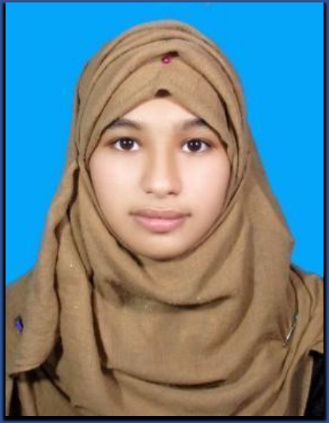



 **: jasiasheen7**[**@gmail.com**](mailto:sifatj08@gmail.com)



To run a responsible position where I could use my interpersonal skills, creativity and above all my learning experiences in order to develop my personal skill, career and as well as to contribute to the welfare of the country.



**BA (Hon's)**

Institute : Lalmonirhat Govt. Collage.

Subject : History

Year : 2023 (Continue 3rd Year)

Board : National University.

**H.S.C**

Institute : Lalmonirhat Mozida Khatun Mohila College .

Group : General

Result : GPA 4.71 Passing Year : 2020 Board : Dinajpur .

**S.S.C/ Dakhil**

Institute : Lalmonirhat Govt Girls School . Group : General

Result : GPA 4.45 Passing Year : 2018 Board : Dinajpure .



* Ability to identify and solve problems
* Ability to work under tremendous pressure.
* Ability to meet any challenge with high confidence,
* Ability to take responsibility



* Word processing : Microsoft Word, Microsoft Excel, Microsoft Access,

Microsoft Power Point, Bangla and English typing.

*(BTEB 6 Month)*

* Internet : Internet browsing, E-mail and Professional.



* Bengali : Mother Language.
* English : Good command in Speaking, and writing.

**Name : Jasia Jannati Sheen Father’s Name : Sujan Islam Mother’s Name : Jaherun Naher Date of Birth : 25 June 2002**

**Religion : Islam**

**Nationality : Bangladeshi by birth National ID No** **4658560141**

**Sex : Female**

**Marital Status : Married**

**Height : 5.1”**

**Weight : 50 kg**

**Blood group : O+**



Hardworking, Honesty, Sincere, self-motivated, self-confident, Self-conscious, Social, Adjustable, Purposive, Visionary and Creative.



* **Present Address**:

Vill: Ucapari, P.O: Lalmonirhat Sador, P.S: Lalmonirhat, Dist: Lalmonirhat.

**Jasia Jannati Sheen Date: …………………….…**